Wool CE PRIMARY SCHOOL & PRE-SCHOOL


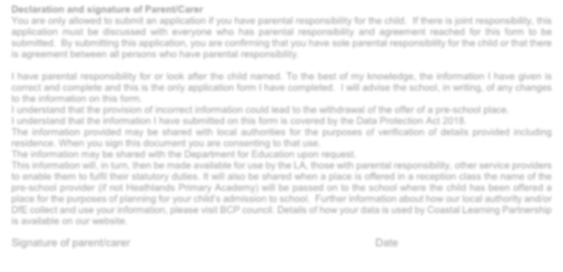

REGISTRATION FORM

CHILDS DETAILS Boy □ Girl □

Child’s Legal Surname: _______________________________________________________________________________

First Name: ___________________________ Middle Name (s): ______________________________________

Known as: ______________________________________ Date of Birth: ____________________________________

Proof of Date of Birth: ___________________________ (Birth certificate/Passport etc.)

Name of current or previous Nursery/Pre-Schools _________________________________________________________

Does your child have a sibling/relative already on roll at Wool CE Primary School? Yes □ No □

Name: _____________________________ Date of Birth: __________________ Relationship to child ___________________

Year Group: __________________ Does the sibling live at the same address as your child? Yes □ No □

Sessions required: _________________________________________________________________________

Please specify day(s) and session(s) _____________________________________________________________________

Full Day 08:30 – 3:00pm | Morning Session 08:30 – 11:30 | Afternoon Session 12:00 - 3:00pm

Funded 2 yr old 2yr Funding Code 30 hr Funded 3yr old 30hr Funding Code

PARENT / CARER DETAILS

Primary Parent / Carer
Full name: ____________________________________ Relationship to child:

Mr/ Mrs/ Ms/ Dr/ Other _________________ Mother □
Address: _____________________________________ Father □
_______________________________________________ Step parent □
_______________________________________________ Foster Parent □
_______________________________________________ Social Worker □
Parental Responsibility: Yes □ No □ Are you a member of HM Armed Forces? Yes □ No □
Telephone Numbers: Home: ________________________ Work: ______________________

Mobile: _______________________________________ Email Address: ________________________________

MEDICAL
Does your child have any Special Medical Needs including any developmental concerns (please detail):
____________________________________________________________________________________________

Any Special Dietary Requirements (please detail):
______________________________________________________________________________________________
Any Allergies (please detail):
______________________________________________________________________________________________
______________________________________________________________________________________________
Please detail any medication (e.g. inhalers/epi-pens etc.)
______________________________________________________________________________________________
Does your child have a legal document called an Education Health or Care Plan? YES/NO (please circle)

Declaration and signature of Parent/Carer

You are only allowed to submit an application if you have parental responsibility for the child. If there is joint responsibility, this application must be discussed with everyone who has parental responsibility and agreement reached for this form to be submitted. By submitting this application, you are confirming that you have sole parental responsibility for the child or that there is agreement between all persons who have parental responsibility.

I have parental responsibility for or look after the child named. To the best of my knowledge, the information I have given is correct and complete and this is the only application form I have completed. I will advise the school, in writing, of any changes to the information on this form.
I understand that the provision of incorrect information could lead to the withdrawal of the offer of a pre-school place.
I understand that the information I have submitted on this form is covered by the Data Protection Act 2018.
The information provided may be shared with local authorities for the purposes of verification of details provided including residence. When I sign this document, I am consenting to that use.
The information may be shared with the Department for Education _{upon request} .
This information will, in turn, then be made available for use by the LA, those with parental responsibility, other service providers to enable them to fulfil their statutory duties. It will also be shared when a place is offered in a reception class the name of the pre-school provider (if not Wool CE Primary School and Pre-school) will be passed on to the school where the child has been offered a place for the purposes of planning for your child’s admission to school. Further information about how our local authority and/or DfE collect and use your information, please visit BCP council. Details of how your data is used by Coastal Learning Partnership is available on our website.

Signature of parent/carer Date

Terms & Conditions:
1.0 Child Care places. Local Authority 15 and 30 hours Childcare funding for 3 and 4 year olds and 15 hour funding for 2 year olds is available for those children who are eligible under the scheme. The funding is subject to the current and applicable rules and regulations as set by each Local Authority.
2.0 Fees. The following charges apply to those parents accessing LA funding:
2.1 Hours booked over and above the entitlement under a funding scheme will be charged at the current prices as stated on the website.
2.2 Charges for additional extras provided and not covered by a funding scheme.
2.3 Hot food is provided upon request at an additional charge.
2.4 We will invoice you half-termly in advance of the following half-term’s fees which will be due within 14 days of the date of the invoice.
2.5 All sessions booked must be paid for regardless of whether your child attends. No refunds will be given for sessions missed due to sickness or holidays.

3.0 Attendance: There is an expectation of regular attendance and if this is not met, we reserve the right to withdraw your child’s place in accordance with the Local Authority funding agreement.
4.0 Parent’s Commitments & Responsibilities:
4.1 You must collect your child in person. If you arrange for someone else to collect your child, then you must contact the school office prior to collection to inform us of the arrangements and obtain a password if appropriate.
4.2 To advise the School in writing of any changes to the details provided in the enrolment form before the changes take place or as soon as possible.
4.3 Notify the School & Nursery of any allergies your child may have, or develops, whilst they attend the Nursery and provide the necessary prescribed medication (i.e. Piriton medicine, Auto-injector).
4.4 To inform the School if you are planning to move your child to another setting and give the required 4 weeks’ notice in writing.

