Welcome to summer 2. We hope you had a lovely half term. This curriculum leaflet is designed to give you an overview of what your child will be learning about this half term. If you have any questions or need any support, please do not hesitate to see a member of staff in the Early Years team.
Our topic this half term is- At the seaside.
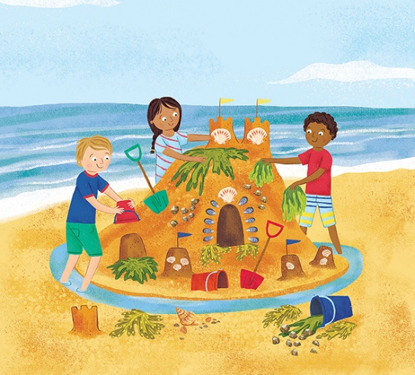
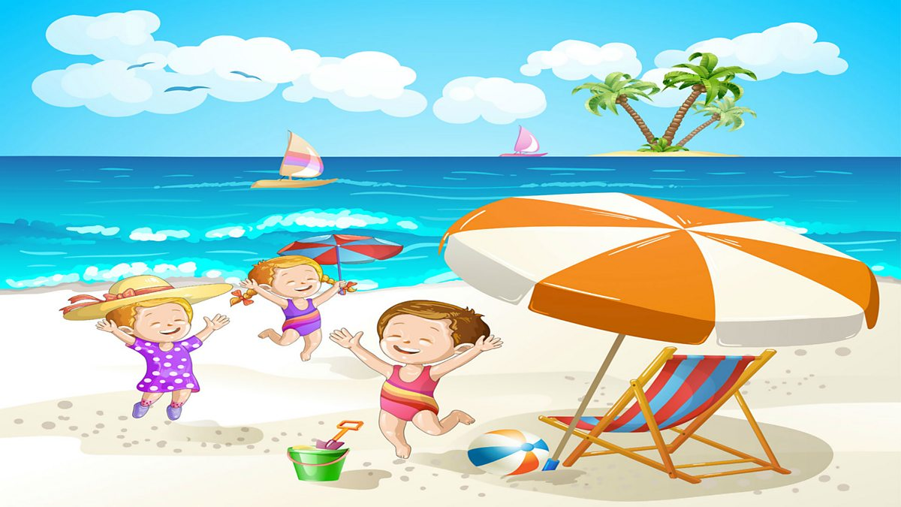

Personal, social and Emotional Development
Manage their own needs.
Know people can feel more than 1 emotion at once.
Think about the consequences of actions.
Think about others point of views.
Reflect on a conflict.
Give praise to others.
Use their knowledge about what is healthy and unhealthy to make sensible choices about the foods they eat.
Know about sun safety.
Be confident to try new activities and show independence, resilience and perseverance.
SCARF- Growing and changing.
To name and describe the different seasons.
Life stages of plants, animals and humans.
To name parts of the body using the correct vocabulary.

Communication and language
Explain their needs, thoughts and feelings using full sentences.
Use talk to work out problems and organise thinking.
Use talk to take on different roles during imaginative play.
Use props and materials to enhance imaginative play.
Use the correct tense when speaking.
Give more detail to explain what they think about why something happens.
Hold conversations which respond to something the other person said.
Make comments about what they have heard and ask questions to clarify their understanding.
Participate in small group, class and one-to-one discussions, offering their own ideas, using recently introduced vocabulary.
Use a range of conjunctions.
Listen attentively and respond to what they hear with relevant questions, comments and actions.

Physical development
To have a comfortable tripod grip. To hold a pencil effectively in preparation for fluent writing.
To use a range of small tools, including scissors, paint brushes and cutlery.
Begin to show accuracy and care when drawing.
Form taught letters correctly both lower and upper case.
Negotiate space and obstacles safely.
Move with energy, such as running, jumping, dancing, hopping, skipping and climbing.
Adjust speed and change direction.
Throw, catch, kick and pass a large ball.
Demonstrate strength, balance and coordination when playing.
Take turns, work as a team and understand the rules of different games. Show the school values when playing different games.
To develop their ability to balance an object using a racket.

Literacy
To read some common exception words
To use phonic knowledge to decode regular words and read them aloud accurately.
Blend words of more than 1 syllable.
Say what part of the story they like the best and why.
Talk about their favourite stories, comparing them to each other.
Recognise that additional information may be contained in illustrations, diagrams etc.
To predict what could happen next in a story.
Use story telling language- once upon a time, happily ever after.
Use and understand recently introduced vocabulary during discussions about stories, non-fiction, rhymes, poems and role play.
Re-read a sentence to check it makes sense.
Edit with a teacher to apply knowledge of misspelt words.
Write short sentences with words with known sound letter correspondence using a capital letter, full stop and finger spaces.
Sequence a series of sentences orally before writing.
To write recognisable letters of a similar size.

Maths
Continue to develop their counting skills, counting larger sets as well as counting actions and sounds.
Explore a range of representations of numbers, including the 10 frame, and see how doubles can be arranged in a 10 frame.
Compare quantities and numbers, including sets of objects which have different attributes.
Explore ‘1 more than’ and ‘1 less than’ numbers within 10.
Continue to identify when sets can be subitised and when counting is necessary.
Secure knowledge of number facts through varied practice.

Expressive arts and Design
To know that Andy Goldsworthy uses natural objects to create artwork.

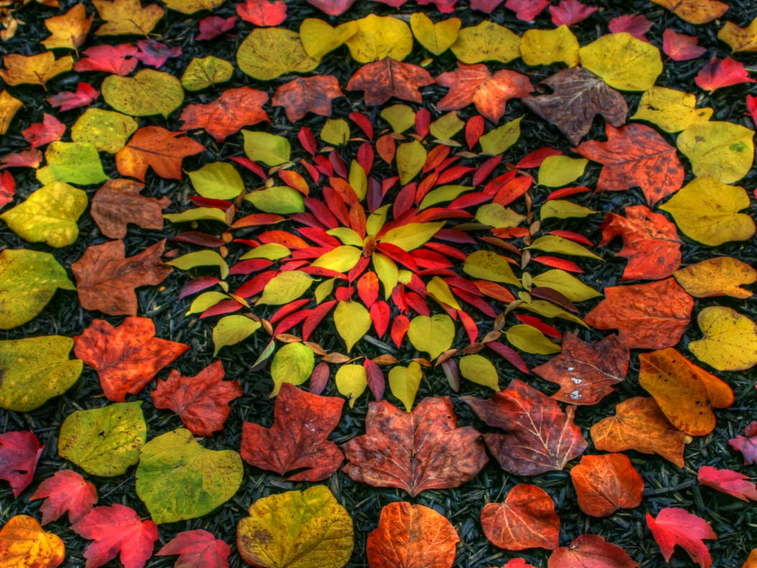

Understanding the world
Explore seasides. What do we see at the seaside? What do we do at the seaside? How can we look after the seaside? To name features of a seaside.
Look at seaside holidays now and in the past.
Explore the seasons. Explore the natural world around them.
Know how to keep ourselves safe in the sun.
Explore sea animals.
RE
How can we care for our wonderful world?


The children are the ‘Boss’ of their own learning and may have other ideas, based on their interests. We are, therefore, flexible in our planning to meet your child’s needs and to personalise their learning. Please feel free to share any more ideas as our topic progresses.

